HIRING PROCESS ANALYTICS

- DATA CLEANING AND OVERVIEW OF THE DATA
- Changing Data Format into one Format
Using Power Query's Locale Settings
- Load the data into Power Query:
  - Data → Get & Transform → From Table/Range
- Right-click the date column → Change Type → Using Locale
- In the dialog:
  - Select "Date/Time" as the type
  - Choose "English (United States)" as the locale (or your appropriate locale)
  - Click OK

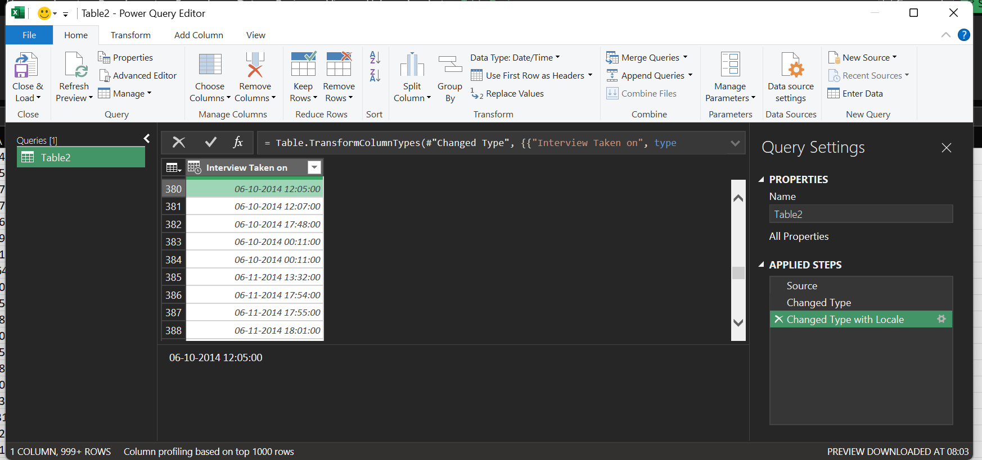

- In the Power Query Editor:
  - I've applied all the transformations
  - All columns should show the correct data types (dates as Date/Time)
- Click "Close & Load" in the Home tab
  - This will return the data to Excel as a new table
  - By default, it creates a new worksheet with the data

- Find and Replace in Event _name column

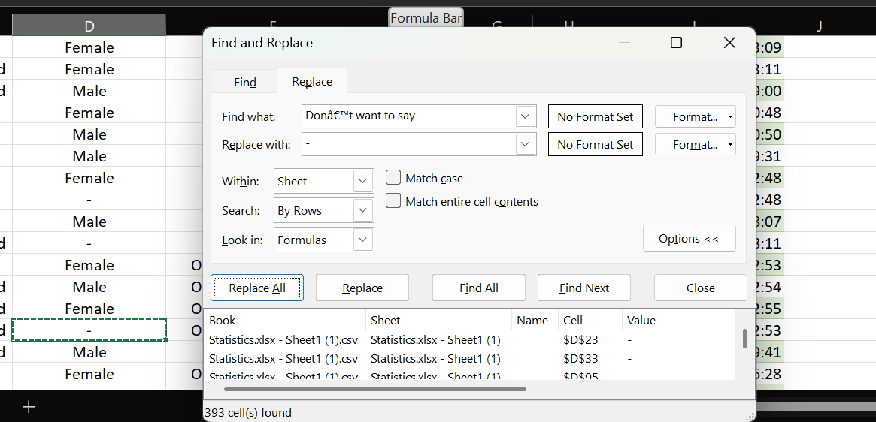

Replace "-" with "Not Specified":

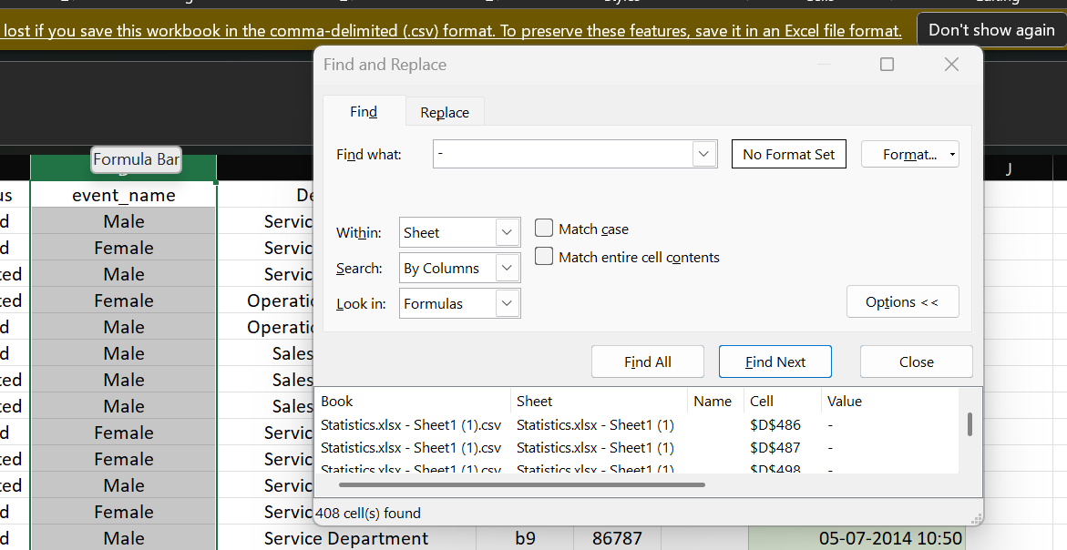

In deleting rows it will remove valuable information in those rows
- If statistical measures are used, Mode could technically show the most common gender, but would:
  - Introduce bias
  - Create false precision
  - Potentially misrepresent individuals' identities
- Best practice: Add a new category like "Unspecified" or "Not Disclosed".Why better:
  - Preserves all data records
  - Maintains integrity (gender shouldn't be imputed like numerical data)
  - Ethical approach to personal identity data

- Filling the space in Post_name
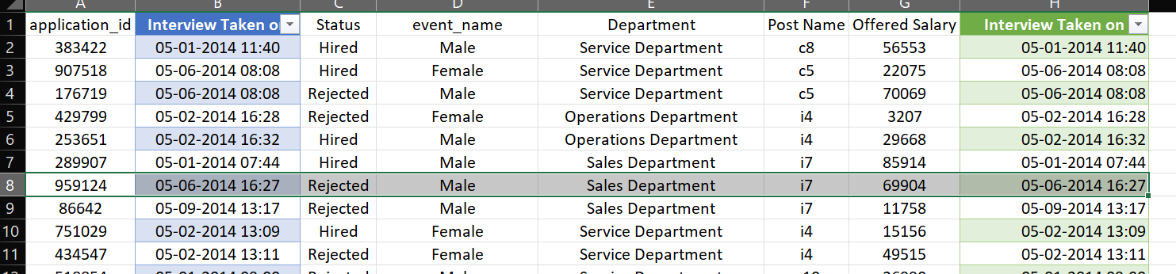
Since sales department have only i7 that’s why it is filled with i7.
- In the Salary column
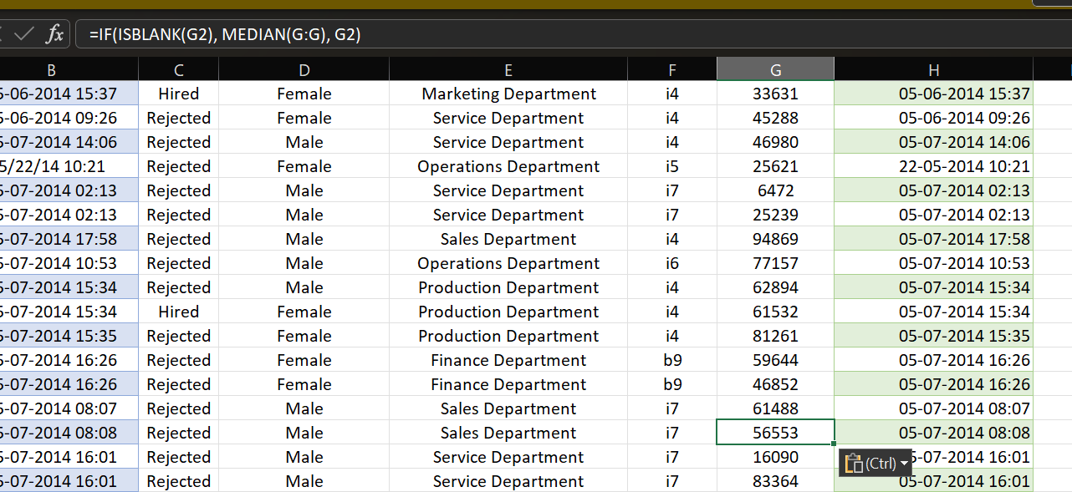
In the Salary column only one blank was present
In Numerical values we use Mean or Median

Average/mean for salary imputation - salaries are typically right-skewed
Median for salary imputation- Maintains the salary distribution pattern specific to that job role

- Clubbing of data
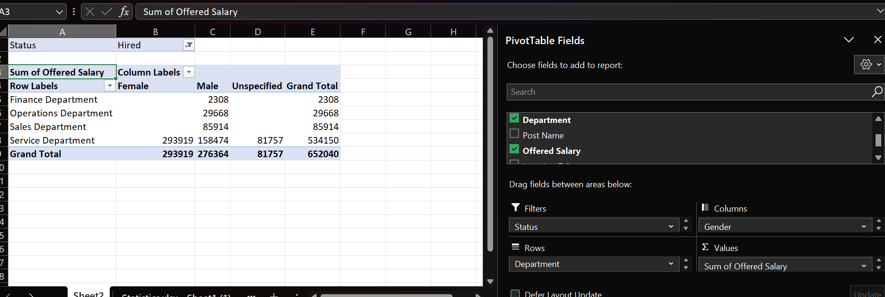
It seems the average salary of males is less than the average salary of females
All the females works in Service Department only.

- Statistical Analysis
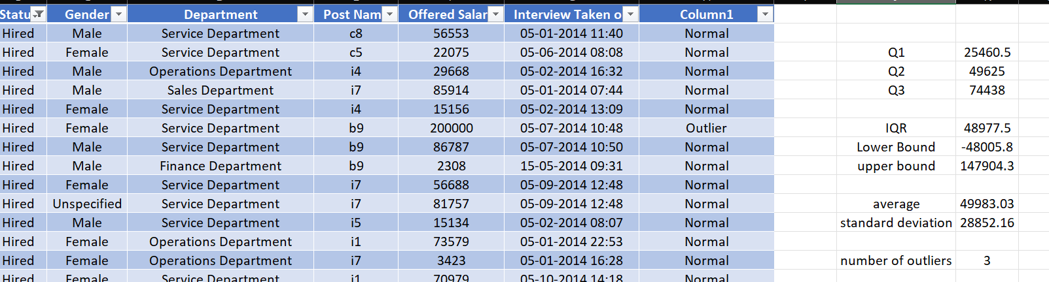
From offered Salary of the Hired Candidates
Q1 | 25460.5
Q2 | 49625
Q3 | 74438
IQR | 48977.5
Lower Bound | -48005.8
upper bound | 147904.3
average | 49983.03
standard deviation | 28852.16
number of outliers | 3

- Analytics Part

A. Hiring Analysis: The hiring process involves bringing new individuals into the organization for various roles.
Your Task: Determine the gender distribution of hires. How many males and females have been hired by the company?
no. of hired male | 2563
no. of hired female | 1856
Formula =COUNTIFS(B:B, "Hired", C:C, "Male")
=COUNTIFS(B:B, "Hired", C:C, "Female")

B. Salary Analysis: The average salary is calculated by adding up the salaries of a group of employees and then dividing the total by the number of employees.
Your Task: What is the average salary offered by this company? Use Excel functions to calculate this.
average salary of hired candidates | 49752.9 | AVERAGEIF(B:B, "Hired", F:F)
average salary of all candidates | 49983.03 | AVERAGE(F:F)

C. Salary Distribution: Class intervals represent ranges of values, in this case, salary ranges. The class interval is the difference between the upper and lower limits of a class.
Your Task: Create class intervals for the salaries in the company. This will help you understand the salary distribution.
Working: =COUNTIFS('working sheet'!F:F, ">=0",'working sheet'!F:F,"<=5000") and so on
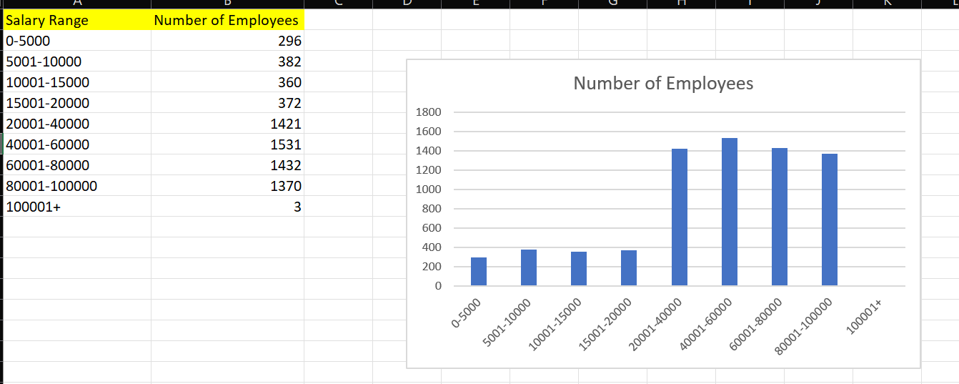

D. Departmental Analysis: Visualizing data through charts and plots is a crucial part of data analysis.
Your Task: Use a pie chart, bar graph, or any other suitable visualization to show the proportion of people working in different departments.

Working---- =UNIQUE('working sheet'!D:D) #to find the unique department values
=COUNTIF('working sheet'!D:D,Sheet4!A2) #to count number of employees in each department
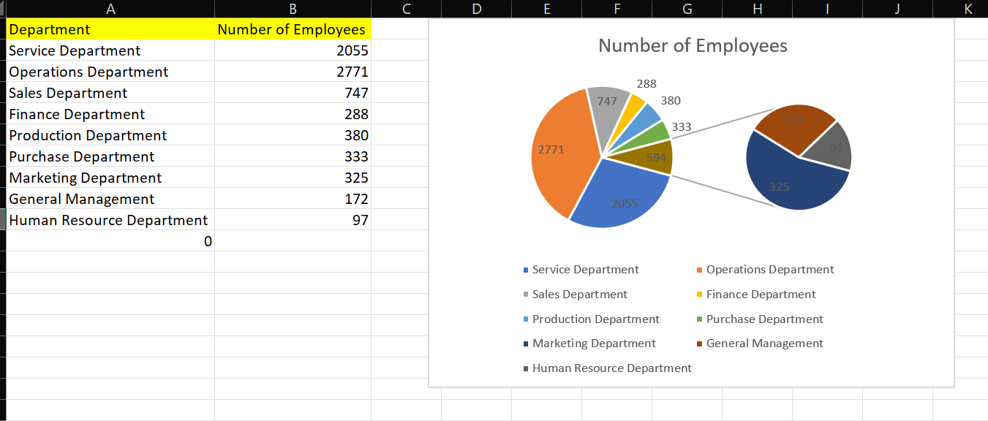

E. Position Tier Analysis: Different positions within a company often have different tiers or levels.
Your Task: Use a chart or graph to represent the different position tiers within the company. This will help you understand the distribution of positions across different tiers.

Working---- =UNIQUE('working sheet'!E:E) #to find unique values of positions
=COUNTIF('working sheet'!E:E,Sheet5!A3)# to find number of employees at that particular position

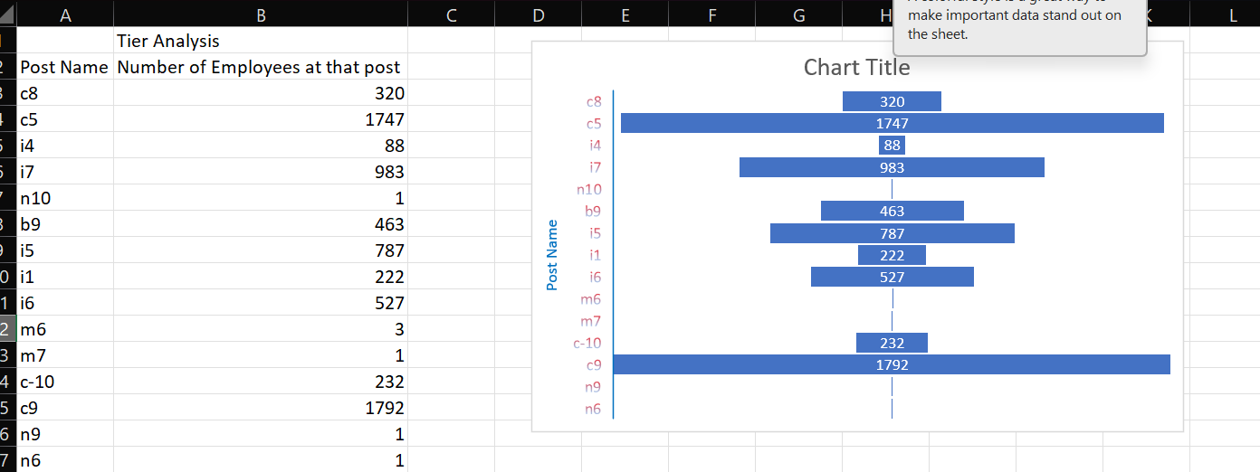

- Description

Project Description
This project analyzes hiring trends, salary distribution, and workforce structure to gain insights into the company's recruitment process. It involves data cleaning, statistical analysis, and visualization using Excel.
Approach
The data was cleaned, outliers were removed using the IQR method, and key metrics were calculated using Excel formulas. Charts and graphs were created to visualize hiring patterns, salary ranges, and departmental distributions.
Tech-Stack Used
Microsoft Excel 2022 was used for data analysis, employing functions like COUNTIF, AVERAGEIF, IQR Calculation, and creating Pivot Tables and visualizations.
Insights
- More males were hired than females (2,563 vs. 1,856).
- The average salary of hired candidates is 49,752.9, with most salaries falling between 40,000 - 80,000.
- Sales & IT depProject Description
This project analyzes hiring trends, salary distribution, and workforce structure to gain insights into the company's recruitment process. It involves data cleaning, statistical analysis, and visualization using Excel.
Result
The project provided insights into workforce distribution, hiring trends, and salary gaps, helping HR make informed decisions on recruitment and compensation strategies.

